Herghelzumar Supplement as composed by Cyrus, Seer of Liosne.

Sections of this document

1. General Statement & Tables

2. Races. Common: humans, dwarves, elves and half-aurks. Uncommon: half-elves. Rare: Abaxhwalile and half-demons.

3. Classes. Common: fighter, rogue and cleric. Uncommon: ranger, wizard, sorcerer and druid. Rare: barbarian, shaman, warlock and samurai.

4. Weapons. Slashing, crushing, stabbing, cleaving, piercing, missile and two-handed.

5. Gods. Krása, Vasara, Egükia, Kratnik, Smojākura, Kallo, Brann, Cefnør and Viedan.

6. Calendar.

General Statements:

1. I find the 3.5 roll20 mechanism the best D&D has to offer to date. That being said, the Skills incorporated in this version kill the role playing and flow of the game. For example, rolling for intimidation, diplomacy and the like. This aspect of the game should be played by ear.
2. All characters can wear any armor/shield they like. The only negative is spell failure.
3. I’m too lazy for attack of opportunity, so beware feats that add some benefit to this.
4. I’ve devised a weapon skill/proficiency system that divides weapons into 7 categories. The only class that can pick from all seven is the Fighter. For more information, see the section 5 of this document. You can also check the table below for a quick look.
5. Initiative equals your dexterity score. You can have modifiers, like improved initiative, weapon modifiers, magic items, etc... Your dex bonus does not add to this score. If you’re dex is 18, your initiative is 18.
6. The world I’ve created is very metal. The races on it therefore represent various metal bands. If you guess the bands, you win a prize.

Tables:

Races of Herghelzumar:

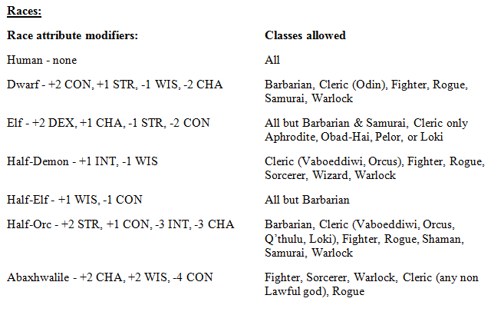

Level Bonuses:

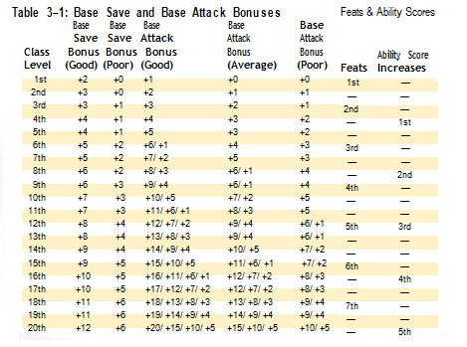

Weapon Proficiencies:

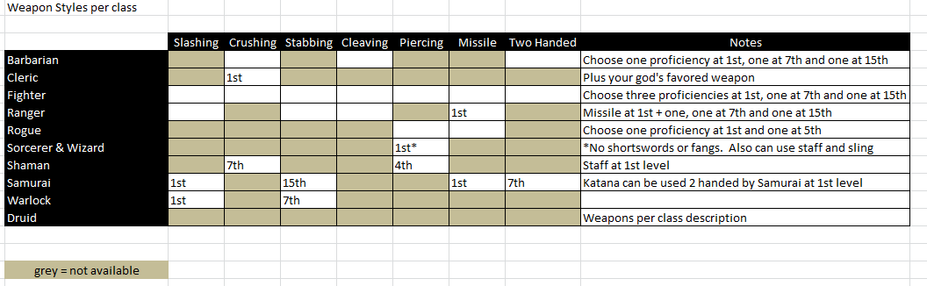

Races. The following notes are addendums to Race descriptions in the 3.5 PHB, except for Half-Demons and Abaxhwalile.

Humans:

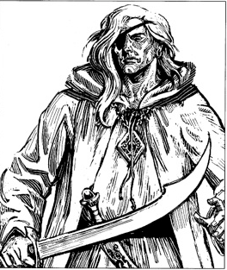

Viedan fell in love with Cefnør ten thousand years ago. Their love was so tortuous and her heartache so strong that she swore to never love again and took a vow of chastity. Cefnør lost his mind and jumped from the highest cliff into the ocean. Because his love was so great he did not drown, but became transformed into a kraken for a whole year and swallowed a ship a day. From that union humans formed.

The race of humans has adapted well to all climates on Herghelzumar. Sticking mainly to the plains on each continent, they make up more than all the other races combined. With their crossbreeding with elves (especially in Nafir) and orcs (especially in Chasmgorve), the definition of Human has become very muddled over the last 5 centuries.

Humans range from the light skinned and often albino peoples of Oorlog, to the dark skinned wizards of D’Tra. The common people of Zyrous, and the elf blooded Nafirs. They speak 4 main languages, Zyrous, Nafir, D’Tra and Oorlag. Zyrous being the far most common. The ancient Lyrasmic language is still practiced by scholars.

Humans worship all the gods.

Kratnik holds the most sway over Zyrous. The great wolf is most powerful and often causes woe to those who do not show fealty. Although with the rise of Vaboeddiwi, some wonder if his power is waning. Vasara and Egükia have shown some strengthening of followers as people look to turn the tide against the evil.

The Oorlog have equal number of temples to Vasara and Brann.

In D’Tra Viedan, Kallo and Krása all have large numbers of temples.

In Nafir, Krása and Egükia are most commonly worshipped.

Oorlog: Humans of Oorlog resemble Humans of Scandanavia, although albinism very common. The harsh frozen lands of Oorlog harbor only the hardiest of souls. Along with some stout dwarves and frost giants, the Oorlog stand tall against the wicked cold winds. As such, barbarians often travel forth from these cold lands seeking fortune.

D’Tra: Humans of D’Tra resemble Africans. Wizard Kings have rules D’Tra for a thousand years. Three hundred years ago, a great exodus of D’Tra to the Zyrous city of Rimbaus occurred after one mad Wizard King drove out anyone who would not swear allegiance to Orcus.

Zyrous: The humans of the Zyrous continent resemble humans of Western Europe. Constant struggles with orc legions have put these people in great despair recently. Their reliance on the land, and druids, has been their stronghold.

Nafir: Pure bred Humans of Nafir resemble Mediterranean humans. The Nafirian peninsula is home to some of the most advanced and prosperous cities on Herghelzumar. Cocoa, wine and coca exports make a great profit for merchants brave and strong enough to voyage on the sea.

HUMAN RACIAL TRAITS:

Automatic Language: Zyrous, (or native tongue).

Allowed Classes: All

Dwarves:

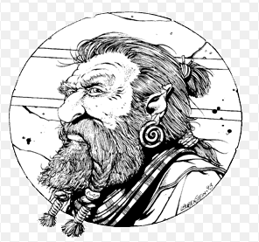

Dwarves of Herghelzumar were born from Vasara’s anvil. Originally they helped him forge the mountains and caverns of the world. In exchange for their servitude he set them free and gave them free will.

The rigid conditions dwarves reside in makes them a hardy people. All are gruff, strong and less susceptible to sickness than the other races. They also love gold, and with their hordes of the stuff, often draw the attention of more wanton enemies. That along with the harsh mountains they live in, make it hard for dwarves to exist in any great numbers.

D’Traehtcht dwarves are currently ruled by King Khalbad. D’Traehtcht dwarves are red or brown bearded and have brown eyes.

Oorlog dwarves are currently rules by King Zigilgil. Oorlog dwarves are black bearded and have blue eyes.

Kryz dwarves have been run from their homes. The remaining few have taken up with the D’Traehtcht clan, or have joined in the battle against Vaboeddiwi. Kryz dwarves are red bearded and have green eyes.

D'Schritzkreikz dwarves are the most reclusive clan. Surrounded by Nafirian elves, they have cut out a good business in gem and jewelry work for sale to them. D'Schritzkreikz dwarves are grey bearded and have grey eyes.

DWARF RACIAL TRAITS

+2 CON, +1 STR, -1 WIS, -2 CHA: Dwarves are stout and tough but tend to be gruff and reserved.

Weapon Familiarity: Dwarves gain the Cleaving weapon style in addition to class weapon style.

Religion: Most dwarves worship Vasara.

Allowed Classes: Barbarian, Cleric (Odin), Fighter, Rogue, Samurai, Warlock.

Dwarves start with +5 GP.

Automatic Languages: Common (Zyrous, Oorlog or Nafir) and Dwarven.

ELVES:

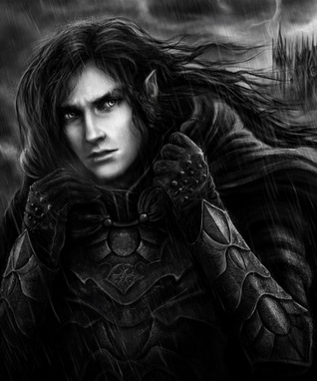

Direct desendents of Kallo and Krása, elves are the most ancient race of Herghelzumar. They consider themselves stewards of the natural world, and work tirelessly to stem the destruction of forests. Often putting themselves at odds with their allies dwarves and humans.

Elves are split into three tribes:

Nafirian elves are light skinned, black or silver haired and violet eyed. They have a very advanced society and have inbred so much with humans of the Nafirian peninsula, that the term Half-Elf does not exist. Most all humans have elf blood, and live in equal numbers with Elves. Worship of Krása is most common among the Nafirian.

Narthyrosian elves are wood skinned, red or brown haired and green eyed. They are ruled by king Narthyr, and have been for millennia. He is very xenophobic and guards the Narthyrosian forest with great magic and will. Few non-Narthyrosian elves have ever entered this forest. Narthyrosians worship Kratnik almost exclusively. Their influence among the Zyrousian Druids is great, although with the murder of all the High-Druids, that influence means little anymore.

The Kuolema, evil subterranean worshippers of Kallo. Miners will infrequently report seeing these elves of coal black skin and white hair. Any attempts to communicate with these beings ends with hostility.

ELF RACIAL TRAITS:

+2 DEX, +1 CHA, -1 STR, -2 CON: Elves are graceful but frail. An elf’s grace makes her naturally better at stealth and archery.

Weapon Proficiency: Elves are proficient in longsword, rapier, longbow, and shortbow in addition to Class weapon styles. Elves esteem the arts of swordplay and archery, so all elves are familiar with these weapons.

Automatic Languages: Zyrous or Nafirian, and Elven.

Adamanite: Elves are susceptible to Adamanite poisoning. This otherworldly metal causes immediate sickness in elves, and they cannot wear the armor or use weapons of this material, even with padding/gloves. Many wicked weapons have been devised with this material to target this weakness.

Allowed classes: Cleric, (Krása, Kratnik, Egükia or Brann), Fighter, Ranger, Rogue, Sorcerer, Wizard, Druid, Shaman, Warlock

HALF-ELVES:

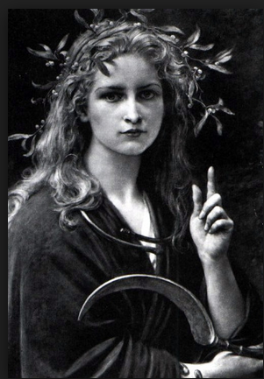

In the Nafirian lands, humans and elves frequently have children, either in wedlock or out. Half-elves are common, and the blending of the races makes it hard to discern humans and elves in this land as this practice has been ongoing for about 800 years.

Rare is the Narthyrosian or Kuolema half-elf.

For game purposes, a half-elf is someone who is 50 – 99 % elf blooded.

HALF-ELF RACIAL TRAITS:

+1 WIS, -1 CON: Wisdom is inborn to half-elves, perhaps ebbing from their split racial persona, while they also inherit the elven weak constitution.

Automatic Languages: Nafirian (usually), and Elven.

Religion: Various.

Allowed classes: All but Barbarian

HALF-ORCS:

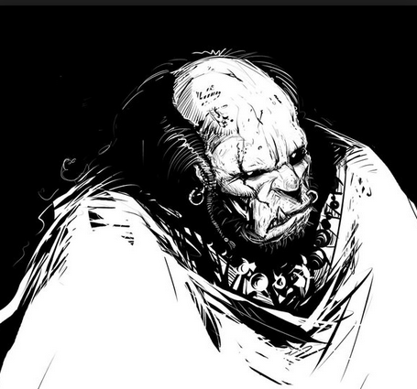

The union between Aurk and Human had never been noted until Smojakura ordered his sickening edict.

Since then Half-Aurks are common within the reaches of his kingdom. And this kingdom is fast growing.

Most Half-Aurks serve in some capacity or other in Smojakura’s army. That being said, Chasmgorve is the origininating spot for most if not all Half-Aurks.

Religion: The god who walks among us, Smojakura is worshipped by most Half-Aurks. Free Half-Aurks worship who they want, but lean towards Cefnør, Kallo or Brann.

HALF-AURK RACIAL TRAITS:

+2 STR, +1 CON, -3 INT, -3 CHA: Half-Aurks are strong, but their aurk lineage makes them dull and crude.

Automatic Languages: Zyrous and Aurk.

Allowed classes: Barbarian, Cleric (Smojakura, Kallow, Cefnør, Brann), Fighter, Rogue, Shaman, Samurai

HALF-DEMONS:

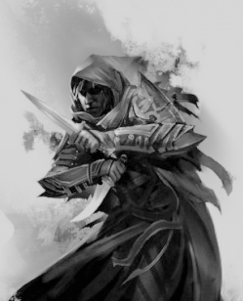

Demons frequently are let loose upon the world as Conjurers attempt to control the foul beasts. Their desire for supremacy over the other worlders is often folly. A Demon will only follow instructions that have bound them magically. And only the most powerful wizards are able to keep these shackles from being torn asunder. It is said that SHAZRIL the Insane personally let loose 100 demons before being eaten by one of the demons.

Before being recalled back to the ether, demons often take advantage of their shape shifting abilities to entice human women. Thus is born the Half-Demon.

Half-Demon children are often killed at birth. Their all black eyes with no iris is seen as an awful omen. But some are swept off by evil priests to have join their ranks. Others are thrown into the woods and raised by wolves. And rarely still are some raised by their parents because they are rumored to be very clever.

Personality: Half-Demons vary in personality as widely as humans, but their increased intelligence brings out a morose tendency in these beings. They are quicker to lash out in anger than humans, and frequently fall into depressed states when things do not go their way.

Physical Description: Half-Demons appear as humans, but for all black eyes. This includes cornea and retina. Most hide this with contact lenses.

Relations: Per human, although dwarves and elves somehow instinctively shy away from half-demons.

Alignment: Half-Demons may be any alignment except LG, LN and NG.

Religion: If any, they will worship Smojakura or Kallo.

HALF-DEMON RACIAL TRAITS:

+1 INT, -1 WIS: Half-Demons are intelligent, but their demonic lineage makes them rash.

Medium: As Medium- creatures, half-demons have no special bonuses or penalties due to their size.

Half-demon base land speed is 30 feet.

Darkvision: Half-demons can see in the dark up to 60 feet. Darkvision is black and white only, but it is otherwise like normal sight, and half-demons can function just fine with no light at all.

Fire immunity: Half-demons have fire running through their veins, and take -2 dmg / die vs fire damage

Depression: If a half-demon rolls a natural 1 to hit, they cannot attack the next round. They are not flat footed during this depressed state.

Automatic Languages: Zyrous, Oorlog, Nafirian or D’Tra; and Abyssal.

Favored Class: Rogue. A multiclass half-demon’s rogue class does not count when determining whether he takes an experience point penalty (see XP for Multiclass Characters, page 60). Vileness runs in a half-demon’s veins.

Allowed classes: Cleric (Smojakura, Kallo), Fighter, Rogue, Sorcerer, Wizard, Warlock

Abaxhwalile:

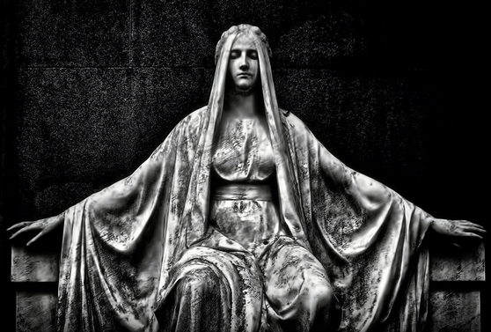

Pale skinned demon worshippers from the far southern hemisphere. They appear rarely in the northern hemisphere on trading ships. They often make secret pacts with demons, and are rarely trusted by more knowledgeable folk. Personality wise, most would describe the Abaxhwilile as arrogant and cunning.

Physical Description: Appearing as a human, but with light grey skin, white hair and light blue eyes, having no facial hair. Susceptible to disease, most are covered with scars or open wounds. They cover these up with tattoos of gauche abstractions. Their clothing tends to be frilly and embroidered with precious metals.

Relations: Trusted by few.

Alignment: Any non lawful.

Abaxhwilile Lands: Northerners who travel to the Abaxhwilile homelands, describe an arid land. Sparse and hot, the sea voyage is rarely made, except by traders looking for odd spices, or giant scorpion blood, (healing potions).

Religion: Clerics tend to be devout followers of Kallo, although in their language he is known as Kifo. Others worship as they see fit.

Abaxhwilile RACIAL TRAITS:

+2 CHA, +2 WIS, -4 CON: Wise and charming, Abaxhwilile have a hard time keeping their lunch down.

Medium: As Medium- creatures, Abaxhwilile have no special bonuses or penalties due to their size. Abaxhwilile base land speed is 30 feet.

Automatic Languages: Abaxhwilile

Favored Class: Sorcerer/Cleric. A multiclass abaxhwilile’s sorcerer or cleric class does not count when determining whether he takes an experience point penalty (see XP for Multiclass Characters, page 60).

Allowed classes: Fighter, Sorcerer, Warlock, Cleric (any non Lawful god), Rogue

Classes:

Following classes taken from D&D 3.5 PHB, excepting skills and weapon styles/proficiencies. **Barbarian**, **Cleric**, **Fighter**, **Ranger**, **Sorcerer**, **Wizard** (including specialists) & **Druid**

Following classes taken from D&D Wiki, excepting skills and weapon styles/proficiencies. **Shaman** & **Samurai**

<http://www.dandwiki.com/wiki/Shaman_(3.5e_Class)>

<http://www.dandwiki.com/wiki/Samurai_(3.5e_Class)>

**Warlock** taken from D&D 5 PHB, excepting skills and weapon styles/proficiencies.

**Rogue** taken from D&D 3.5 PHB, excepting skills and weapon styles/proficiencies, plus modifications on the following page.

**Rogue:**

Since skills are no longer in play, I’ve reached back to D&D 2.0 for the Thief skills employed there, with a couple of additions.

Each skill score will be added to your roll on a d20, and must beat the DC of the difficulty, as determined by the GM.

At 1st level the rogue get 20 points to add to each skill, with no skill getting more than 7 points. Every level afterwards the character gets 10 points to disperse, with no skill getting more than 5.

Ability modifiers:

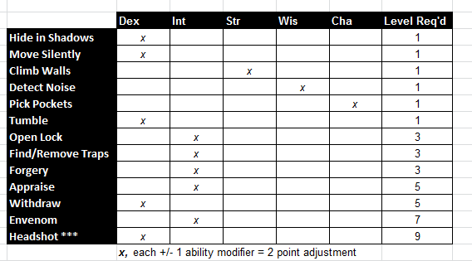

Race modifiers:

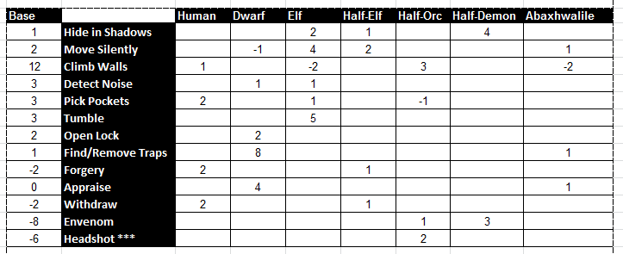

Withdraw is the ability to maneuver out of combat situations with amazing skill. Consider it for use when cornered.

Headshot is just as it sounds, a hit to an opponent’s head. This makes the subject temporarily dazed. Basically you’re negating their move if their initiative is after yours. This comes into play since we’re using static inititative. They are also flat footed (no dex bonus to AC). **Roll a d20 vs subjects AC, adding your Headshot score only. \*\*\***For each level the subject has above yours, subtract 2 from your skill score. This does not subtract from your die roll.**\*\*\***

Weapon Styles: *(check files weapons.xls for further details)*

Weapons are separated into 7 styles. Slashing, Crushing, Stabbing, Cleaving, Piercing, Missile and Two Handed.

Slashing = Swords, excluding shortswords.

Crushing = Maces, morningstars, hammers, flails and clubs

Stabbing = Spears

Cleaving = Axes

Piercing = Shortswords and daggers

Missile = Bows, crossbows and slings

Two Handed = any Two Handed

Class Weapon Style:

Fighters: At 1st level fighters are proficient in any 3 weapon styles. Add one at 7th and one at 15.

Barbarians: At 1st level barbarians are proficient in either two-handed, crushing or cleaving (pick one). Add one at 7th and one at 15.

Rangers: At 1st level rangers are proficient in missile and either slashing, cleaving or stabbing. Add one at 7th and one at 15.

Samurai: At 1st level samurai are proficient in slashing and missile. At 7th level they gain two-handed and at 15 they add stabbing.

Thieves: At 1st level thievs are proficient in piercing or missile weapons. An additional proficiency may be added at 5th level.

Clerics: At 1st level clerics are proficient in crushing weapons, staffs and slings, (plus their god’s favored weapon).

Mages and Sorcerers are proficient in staff, sling and any piercing weapon except shortswords or fangs.

Warlocks are proficient with slashing at 1st level and stabbing at 7th level.

Shamans get staff at 1st level, piercing at 4th level and crushing at 7th.

Druids weapons per class description.

Elves are always proficient with longswords, longbows and shortbows, in addition to class weapons.

Dwarves are always proficient with all cleaving weapons, in addition to class weapons.

